INDIA CITY LIVABILITY INDEX

MASTER OF COMPUTER APPILICATIONS



By

RUCHIRA RAMESH YALLUR

1BY25MC086

II Semester ‘B’ Section

Under the Guidance of

Dr. SHIVAKUMARA T

Associate Professor

Department of MCA
BMSITM
Bengaluru

Department of Master of Computer Applications
(Accredited by NBA, New Delhi)
BMS Institute of Technology & Management
(Autonomous Institution under VTU)
Bengaluru
September -2026

1. INTRODUCTION

India is a rapidly urbanizing nation with over 50 major cities, each offering a distinct blend of opportunities and challenges. A city that excels in education and job connectivity may suffer from severe air pollution and high cost of living, while an affordable city might lack quality healthcare and public transport. Currently, no unified platform exists that allows individuals to compare Indian cities across multiple livability dimensions based on their personal priorities.
The "India City Livability Index" project addresses this gap by building an interactive, data-driven web dashboard that aggregates publicly available data across seven key livability dimensions for 30 major Indian cities. Users can adjust priority sliders to assign personal importance weights to each dimension, and the dashboard dynamically recalculates city rankings and recolors an interactive India map in real-time. The project also applies machine learning techniques — Principal Component Analysis (PCA) and KMeans Clustering — to identify natural groupings among cities and reveal hidden patterns in the data.
This project is built entirely using free, open-source tools (Python, Streamlit, Plotly, scikit-learn) and publicly available data sources (government portals, free APIs, and open datasets), making it fully reproducible.

2 .LITERATURE SURVEY

Reference | Description | Limitation Addressed by This Project
Ease of Living Index (MoHUA, Govt. of India) | Ranks 111 Indian cities across pillars: Quality of Life, Economic Ability, Sustainability, Governance. Published annually. | Fixed weights — users cannot personalize. No interactive dashboard. Data not openly downloadable.
Mercer Quality of Living Survey | Global city ranking across 39 factors for expatriate assignments. Covers a few Indian cities. | Targets expatriates, not Indian residents. Paid/proprietary data. Very few Indian cities included.
Numbeo Cost of Living Index | Crowdsourced cost-of-living comparison across global cities. | Covers only cost dimension. No composite livability score. No India-specific health or safety data.
WHO Global Air Quality Database | PM2.5 and PM10 data for cities worldwide. | Air quality is only one dimension. No integration with Indian safety, education, or healthcare data.
NCRB Crime in India Report | Annual publication of crime statistics by NCRB across Indian cities. | Raw data only — no scoring, no comparison framework, no visualization dashboard.

3. PROBLEM STATEMENT WITH AIM AND OBJECTIVE

Problem Statement
There is no single “best city” in India because the definition of “best” varies from person to person. A student prioritizes education and affordability. A family with children prioritizes safety, air quality, and healthcare. A retiree prioritizes climate and healthcare. A remote worker prioritizes affordability and internet connectivity. Existing city rankings (such as the Ease of Living Index by MoHUA) use fixed, non-customizable weights and do not allow personal preference-based re-ranking.
Aim
To design and develop a personalized, interactive, data-driven web dashboard that ranks major Indian cities on livability according to weights the user themselves control, supported by machine-learning-based insights into natural city groupings.
Objectives
- To collect, clean, and integrate data from 7 different public sources covering climate, air quality, safety, education, affordability, healthcare, and connectivity for 30 Indian cities.
- To develop a normalized scoring framework (0–100 scale) for each livability dimension, enabling fair cross-city comparison.
- To implement a weighted composite index that allows users to rank cities based on personalized priority weights.
- To apply PCA for dimensionality reduction and KMeans clustering to identify natural city tiers and groupings.
- To build an interactive Streamlit web dashboard featuring a clickable India map, real-time priority sliders, radar charts for city profiling, and a city-vs-city comparison tool.
- To deploy the application on a free cloud platform (Streamlit Cloud) for public access.

4. SDG ALIGNMENT
The project's purpose — helping citizens make informed, personalized decisions about where to live based on transparent, multi-dimensional public data — aligns with several United Nations Sustainable Development Goals (SDGs).
SDG | Goal | How This Project Aligns
SDG 11 | Sustainable Cities and Communities | Directly supports the goal of making cities inclusive, safe, resilient, and sustainable by giving citizens a transparent, data-backed way to evaluate urban livability across environmental, safety, and infrastructure dimensions.
SDG 3 | Good Health and Well-Being | Incorporates healthcare access (doctors/beds per lakh) and air quality (PM2.5) as core scoring dimensions, surfacing cities where health outcomes and environmental conditions may be at risk.
SDG 9 | Industry, Innovation and Infrastructure | Uses the Connectivity dimension (metro, airport, rail, broadband) to reflect a city's infrastructure maturity, encouraging data-driven infrastructure comparison and awareness.
SDG 10 | Reduced Inequalities | By exposing trade offs such as “affordable cities often have weaker health infrastructure,” the project highlights regional inequality in access to services, supporting more informed public discourse and policy attention.
SDG 17 | Partnerships for the Goals | Built entirely on open government data (MoHUA, NCRB, CPCB, NIRF, data.gov.in) and free/open-source tools, demonstrating how open data ecosystems can be reused to create public value.

5.METHODOLOGY
5.1 Data Collection
Data is collected from 7 sources: two via free API calls, three via direct CSV downloads from government/open data portals, and two via manual compilation from reference websites — OpenWeatherMap API (Climate), Kaggle CPCB dataset (Air Quality), Kaggle/NCRB dataset (Safety), NIRF Rankings (Education), Numbeo (Affordability), data.gov.in NHP (Healthcare), and Wikipedia/TRAI (Connectivity).
5.2 Data Processing & Scoring
- All 7 datasets are merged on the “city” column into a single master DataFrame (30 cities × 20+ columns).
- Missing values are imputed using the column median (documented and justified in the notebook).
- Each raw metric is converted to a 0–100 score using MinMaxScaler. For “higher is better” metrics (e.g., doctors per lakh), the score maps directly to 0–100. For “lower is better” metrics (e.g., crime rate, PM2.5), the score is inverted: score = 100 − normalized_value × 100.
- The resulting master CSV (master_livability.csv) serves as the single source of truth for all downstream analysis and the dashboard.
5.3 Weighted Composite Index
The Livability Index is calculated as a weighted average:
Livability Index = Σ (dimension_score_i × weight_i) / Σ (weight_i)
Where weights (1–10) are set by the user via interactive sliders. Pre-built profiles (Student, Family, Retiree, Remote Worker, Job Seeker) provide sensible defaults.
5.4 Machine Learning Models
Model 1 — PCA (Principal Component Analysis): standardizes all 7 features and reduces them to 2 dimensions for visualization; the resulting 2D scatter plot reveals which cities are most similar, and PCA loadings reveal what each axis represents (e.g., PC1 ≈ “infrastructure & development”, PC2 ≈ “comfort & wellness”).
Model 2 — KMeans Clustering: groups the 30 cities into 4 clusters (validated using Silhouette Score), with each cluster named from its average dimension profile (e.g., “Metro Powerhouse” for high education + connectivity but low affordability + air quality). Cluster labels are displayed on the dashboard and help users quickly identify city tiers.

6.MODULE IDENTIFIED
Module | Description | Technology
Data Collection Module | Fetches weather via API, loads CSVs, handles manual data entry | Python, requests, pandas
Scoring & Normalization Module | Applies scoring functions, normalizes to 0–100, handles missing values | pandas, sklearn.preprocessing
ML Analysis Module | PCA projection + KMeans clustering + Silhouette evaluation | scikit-learn
Index Calculator Module | Computes weighted livability index from user-set slider weights | Python (NumPy)
Dashboard — Rankings Page | Interactive India map (Plotly scatter_geo) with colored city dots + ranking table | Streamlit, Plotly
Dashboard — Compare Page | Side-by-side radar charts for any two cities | Streamlit, Plotly (Scatterpolar)
Dashboard — Clusters Page | PCA 2D scatter plot with cluster coloring + tier labels | Streamlit, Plotly
Dashboard — City Detail Page | Full city profile: radar chart, raw scores, national rank per dimension | Streamlit, Plotly

7. TOOLS AND TECHNOLOGIES

Category | Tool / Library | Purpose
Programming Language | Python 3.9+ | Core development language
Data Manipulation | pandas, NumPy | Dataframe operations, numerical computation
Machine Learning | scikit-learn | PCA, KMeans, StandardScaler, MinMaxScaler, Silhouette Score
Visualization | Plotly, Matplotlib, Seaborn | Interactive maps, radar charts, heatmaps, EDA plots
Web Framework | Streamlit | Interactive web dashboard (no HTML/CSS/JS required)
API Communication | requests | HTTP calls to OpenWeatherMap API
IDE | VS Code / Jupyter Notebook | Development and exploratory analysis
Version Control | Git + GitHub | Code management and portfolio hosting
Deployment | Streamlit Cloud (free) | Public hosting of the dashboard

8. TIMELINE USING GANTT CHART

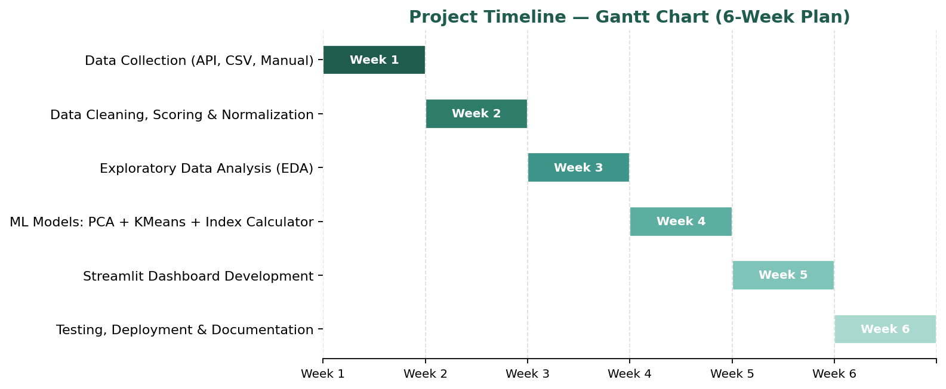
Week | Phase | Deliverable
Week 1 | Data Collection — API calls, CSV downloads, manual compilation | 7 raw CSV files
Week 2 | Data Cleaning, Scoring, Normalization, Master CSV creation | master_livability.csv
Week 3 | Exploratory Data Analysis (EDA) — 10+ visualizations + insights | EDA notebook with charts
Week 4 | ML Models (PCA + KMeans) + Weighted Index Calculator | ML notebook + src/ modules
Week 5 | Streamlit Dashboard (4 pages + map + sliders + radar charts) | Working dashboard on localhost
Week 6 | Testing, deployment to Streamlit Cloud, README, documentation | Live public URL + final report

